Use Case Diagram:

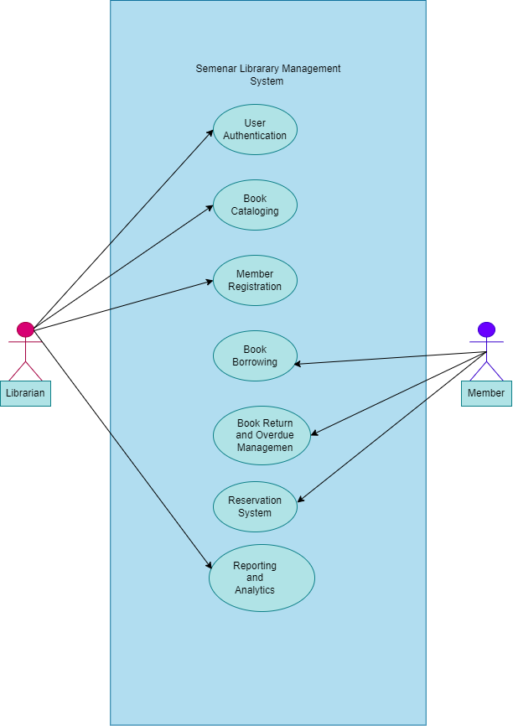

Use Case 1[REQ01]: User Authentication
- Actor: Library Member
- Description: The library member logs into the system using their registered username and password to access their personalized account.
- Preconditions: None
- Postconditions: The member gains access to their account and related functionalities.
Main Flow:
- The member navigates to the login page of the system.
- The system presents fields for entering the username and password.
- The member enters their registered username and password.
- The system validates the credentials.
- If the credentials are valid, the system grants access to the member's account.
- The member can now view their borrowing history, reserved books, and any incurred fines.

Use Case 2[REQ02]: Book Cataloging
- Actor: Librarian
- Description: The librarian manages the library catalog by adding, modifying, and deleting book records.
- Preconditions: Librarian is logged into the system.
- Postconditions: The catalog is updated with new information or removed records.
Main Flow:
- The librarian accesses the catalog management section.
- The system provides options to add, modify, or delete book records.
- If adding:
a. The librarian enters essential details (title, author, ISBN, genre, publication info) of the new book.
b. The system validates the information and adds the new book to the catalog.
- If modifying:
a. The librarian searches for the book to be modified.
b. The system displays the existing information for the book.
c. The librarian updates the necessary fields.
d. The system validates and updates the book's information.
- If deleting:
a. The librarian searches for the book to be deleted.
b. The system displays the book's information.
c. The librarian confirms the deletion.
d. The system removes the book record from the catalog.

Use Case 3[REQ03]: Member Registration
- Actor: Librarian
- Description: The librarian registers new library members, providing them with login credentials.
- Preconditions: Librarian is logged into the system.
- Postconditions: The new member has a registered account with login credentials.
Main Flow:
- The librarian accesses the member registration section.
- The system presents fields for entering required member information (name, contact details, etc.).
- The librarian enters the necessary information.
- The system generates login credentials for the new member.
- The librarian completes the registration process.

Use Case 4[REQ04]: Book Borrowing
- Actor: Library Member
- Description: The library member borrows books from the library's catalog.
- Preconditions: Member is logged into the system.
- Postconditions: The member has successfully borrowed selected books.
Main Flow:
- The member navigates to the book catalog or search section.
- The system displays available books.
- The member selects a book they wish to borrow.
- The system provides information about the book and its availability.
- The member confirms the borrowing request.
- The system generates a due date for the borrowed item.
- The member receives a confirmation of the successful borrowing transaction.

Use Case 5[REQ05]: Book Return and Overdue Management
- Actor: Library Member
- Description: The library member returns borrowed books on time to avoid overdue fines and maintains a good borrowing record.
- Preconditions: Member is logged into the system, has borrowed books.
- Postconditions: The member has returned books, and any applicable fines are calculated.
Main Flow:
- The member accesses their account or borrowing history.
- The system displays borrowed items and their due dates.
- The member identifies books to be returned.
- The member returns the books physically to the library.
- The system updates the status of the returned books and calculates overdue fines, if applicable.
- The member is notified of any incurred fines.

Use Case 6 [REQ06] : Reservation System
- Actor: Library Member
- Description: The library member reserves books that are currently unavailable.
- Preconditions: Member is logged into the system.
- Postconditions: The reserved book is held for the member upon availability.
Main Flow:
- The member searches for a book in the catalog.
- The system displays the availability status of the book.
- If the book is unavailable, the member requests a reservation.
- The system records the reservation and notifies the member.
- When the reserved book becomes available, the member is notified, and the book is held for a specified pickup period.

Use Case 7[REQ07]: Reporting and Analytics
- Actor: Librarian
- Description: Librarians access comprehensive reports and analytics about book circulation, popular books, and member statistics.
- Preconditions: Librarian is logged into the system.
- Postconditions: Librarians have access to the requested reports and analytics.

